Revenue Analysis
Of
Options to Reform
The Federal Estate, Gift and Generation
Skipping Transfer Taxes

Submitted by:
Quantria Strategies
1020 N. Quincy St., Apt. 808
Arlington, VA 22201

Contact Information:
John F. O’Hare
703.395.1848

Submitted to:
Family Enterprise USA
PO Box 27902
1750 Pennsylvania Ave., NW
Washington, DC 20038
ATTN: Pat Soldano

September 2017
Revenue Analysis of Options to Reform the Federal Estate, Gift and Generation Skipping Transfer Taxes

Executive Summary

- Our federal transfer tax system has three related components: the estate tax, a gift tax and a generation-skipping transfer tax (GST).

- For much of its history, wealth transfer taxes were enacted to finance wars; they were never meant to be a major source of government revenue.

- In 2015, the last year for which data are available, approximately 5,000 decedents paid $17.1 billion in federal estate taxes.

- The average estate tax liability was about $3.5 million, but for estates with assets greater than $50 million, this average liability was approximately $28 million.

- This represents only about .2% of adult decedents and about 0.6% of federal government revenues.

- For most of these estates, the single largest component of wealth relates to publicly traded stock (about 25%).

- The second largest component of wealth relates to business assets (23%), and includes real estate partnerships, closely held stock, farm assets, other limited partnerships and other non-corporate business assets.

- Currently, about 600,000 families are likely to be subject to the estate tax in any one year, total personal wealth is approximately $7 trillion.

- In this report, we analyze three standalone options to reform the federal estate, gift and GST taxes that would help reduce the tax burden on business owners. Option A would completely repeal of the federal estate, gift and GST taxes and retain the current law step-up in basis rules. Option B would also completely repeal the estate, gift and GST taxes but replace the current law step-up in basis with a modified regime that would exempt from capital gains tax the value of inherited assets up to the existing personal estate tax exemption amount (currently $5.49 million) and index this amount for inflation occurring after 2018. Option C retains the current estate, gift and GST system and step-up in basis rules, but lowers the maximum estate tax rate to 20%.

- We estimate these options would reduce federal budget receipts by the following amounts for Fiscal Years 2018-2027 for decedents dying on or after January 1, 2018:

Description | Revenue Effect (Billions of Dollars)
Option A: Full Repeal of Estate, Gift and GST taxes; Retain Current Law Step-up. | -280.2
Option B: Full Repeal of Estate, Gift and GST taxes with a Modified Step-up In Basis limited to the amount of the personal estate tax exemption and indexed to inflation. | -184.7
Option C: Maintain the Current Estate, Gift and GST System with Full Step-up in Basis and Reduce the Current Maximum Tax Rate to 20% | -147.2

- In addition, it is likely that the economic burden of complying with the tax, including tax planning to minimize its effects, is probably greater than the revenues collected, suggesting the federal estate and gift tax is an inefficient tax.

- Our estimates assume that each option is a standalone proposal and not part of a larger tax reform package. If the proposals are coupled with a reduction in individual and corporate tax rates – as is currently being contemplated – then the estimated revenue losses would be lower.

Table Of Contents

Executive Summary 1
Table Of Contents 3
Overview 4
Background on the Federal Estate and Gift Tax 4
Current Law 5
Reasons For Change 11
Options For Relief From Federal Estate, Gift and GST Taxes 11
Review Of JCT Estimates and Methodology 12
Revenue Estimates 13
Option A: Complete Repeal of Federal Estate, Gift and GST Taxes 16
Option B: Complete Repeal of Federal Estate, Gift and GST Taxes With a Modified Step-up In Basis 16
Option C: Reduce The Maximum Tax Rate to 20% 16
What Is The Cost Of Complying With The Tax? 18
Conclusions 18
Appendix I – Chronological History of the Estate and Gift Tax 19
Appendix II – Measuring Taxpayer Response to a Tax Change 20

Overview

In this report we present revenue estimates and an analysis of three (3) options to reform the federal gift and estate tax. These reforms range from outright repeal, including a modified carryover of basis regime, to a reduction in the maximum tax rate imposed on estates. Along the way, we also:

- Discuss the historic rationale for the tax and whether these aims have been met.
- Present historical data on the impact of the tax has it affects U.S. households and federal revenues.
- Describe current law and reasons for change.
- Estimate the annual compliance burden for families likely to be affected by the tax.
- In addition, we describe typical estate planning techniques presently used by small- and medium-sized businesses to mitigate and reduce the tax burden.

Background on the Federal Estate and Gift Tax

The U.S. imposed its first tax on wealth transfers in 1797 to help fund the build-up of a strong navy to help protect our young country from outside threats. The tax was temporary and only in place for a few years. For much of its history, taxes on the transfer of wealth were similarly enacted for short periods to fund wars (e.g., the Civil War and the Spanish American War).

The modern estate and gift tax system we have in place today was enacted in 1916 as a way to help pay for World War I when revenues from tariffs fell. The Revenue Act of 1916 imposed a tax on the transfer of wealth from an estate to its heirs. The tax was applied to the total property of the decedent less deductions. A $50,000 exemption was allowed to residents. A graduated rate schedule was imposed, with the rates ranging from 1% on the first $50,000 of the net estate, up to 10% on the value exceeding $5 million.

Significant changes to the estate state were made beginning in 1976 where the present unified credit that linked estate and gift taxes was introduced. This framework created a system where a single, graduated rate was applied to both lifetime gifts and property passed along at death. Also, in 1976 the Generation Skipping Transfer tax (GST) was enacted as were rules relating to carryover of basis, special use valuation and an increased marital deduction.

The top estate tax rate in 1977 was 70% and the exclusion was raised from $60,000 to $120,000. Over the next 20 years, the maximum rate was lowered to 55% while the exclusion was increased to $650,000. Additional, changes were made to the estate tax in 2001 where the exclusion was gradually raised to $3.5 million and the maximum rate reduced to 45%. Because of budgetary rules, the federal estate tax was repealed in 2010 and an optional system was put into place before our current system emerged. Table 1 summarizes the recent history of exclusions, exemptions and tax rates since 1977.

Table 1 – Summary of Estate and Gift Tax Rates and Exemptions, 1977 to 2015

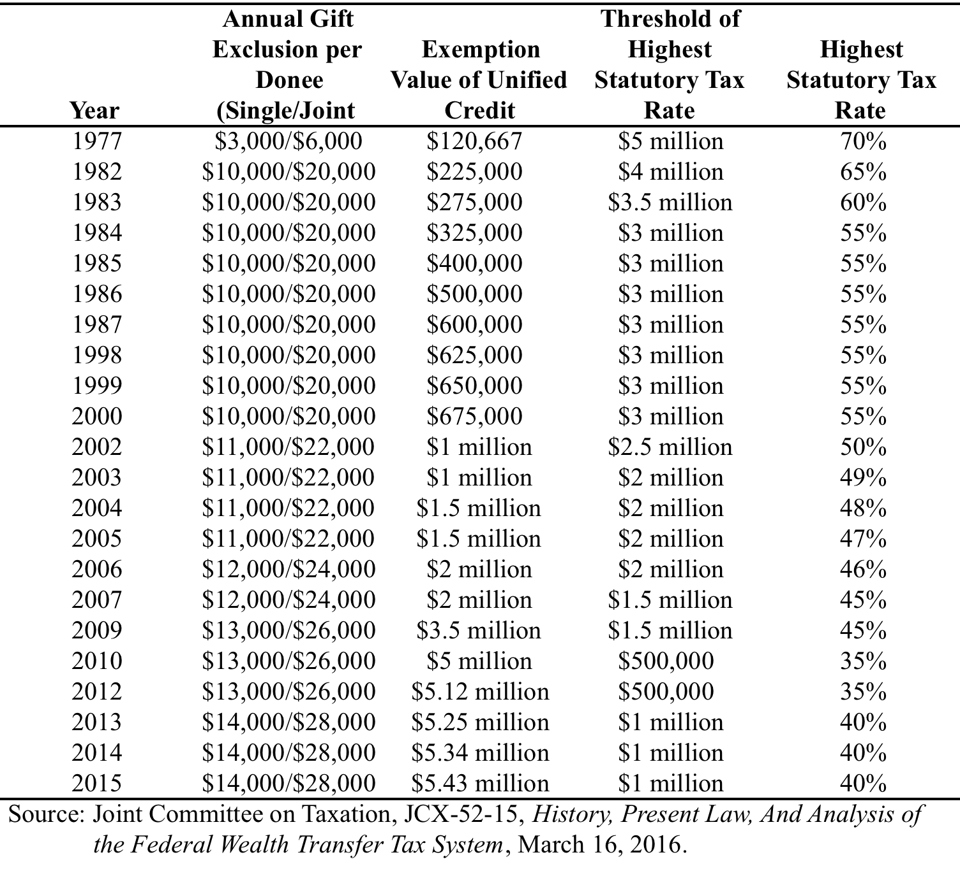

Current Law

In 2017, the effective estate and gift tax rate is 40% and applied to an individual’s cumulative taxable gifts and bequests. A unified credit results in an effective exclusion of $5.49 million. A taxable estate is generally calculated at the fair market value of property passing into the estate minus certain deductions, including a marital deduction for property passing to a surviving spouse and donations to charity. Any unused exemption at the time of death of the first spouse is generally available for use by the surviving spouse.

The gift tax is linked to the estate tax (e.g., a “unified” system) by taking into account lifetime gifts. They share a common exclusion, imposed through the unified credit. In order to calculate the gift tax owed in any one year, the taxpayer first calculates the tentative tax on the combined amount of cumulative current year and prior year gifts. Next the tentative tax on prior year gifts is calculated and subtracted from the tax on the combined total. Finally, any unused unified credit not claimed in prior years is subtracted from the tentative tax to arrive at the current year gift tax.

Individuals are allowed an annual gift tax exclusion for each gift made before taxable gifts are calculated. In 2017, this annual exclusion is $14,000. Married couples can combine their individual exclusions, resulting in an annual gift tax exclusion of $28,000.

A separate tax is imposed on transfers, either directly or in trust, to a beneficiary that is more than one generation below the decedent. This generation-skipping transfer tax (GST) is imposed at a rate of 40% on generation-skipping transfers in excess of $5.49 million (in 2017). Because the GST is a separate, add-on tax on transfers the effective rate can reach 80%.

Table 2 summarizes the impact of the estate tax in 2015, the last year for which data are available. The figures show that about 5,000 families paid $17.1 billion in tax. The average tax liability was approximately $3.5 million but this amount varied substantially by the size of the gross estate. For gross estates in excess of $50 million, the average estate tax was about $28 million.

These figures represent taxable estates. Approximately 12,000 families with gross estates in excess of $5 million were required to file an estate tax return and the total gross estate of all filers was $167.4 billion.

Table 2 – Estate Tax Summary, 2015
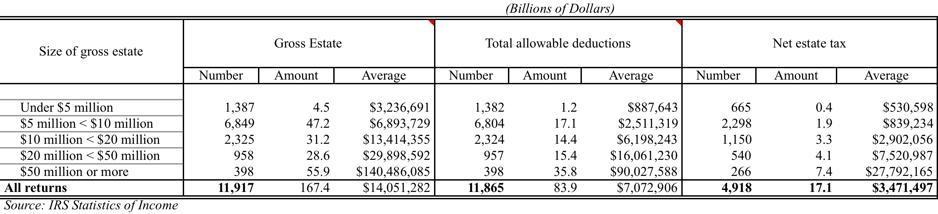

Table 3 demonstrates how the estate tax is calculated, beginning with the gross estate. The 4,918 taxable estates in 2015 reported a gross estate of $88.2 billion. This is the starting point for calculating the tax. From the gross estate, several deductions are allowed including deductions for funeral expenses, executor fees, bequests to a surviving spouse and charitable bequests. The single largest deduction is for bequests to a surviving spouse ($11.3 billion) and the second largest is for charitable bequests ($9.7 billion). Total deductions from the gross estate for 2015 were $28 billion, leaving a total taxable estate of $60.1 billion. Next adjusted taxable lifetime gifts are subtracted from the taxable estate and a tentative estate tax is determined. To the tentative estate tax, adjustments are made for gift taxes paid, the unused exclusion amount for a deceased spouse and any unused unified credits to arrive at net estate tax.

Table 3 Calculation of Estate Tax Liability for Taxable Estates, 2015

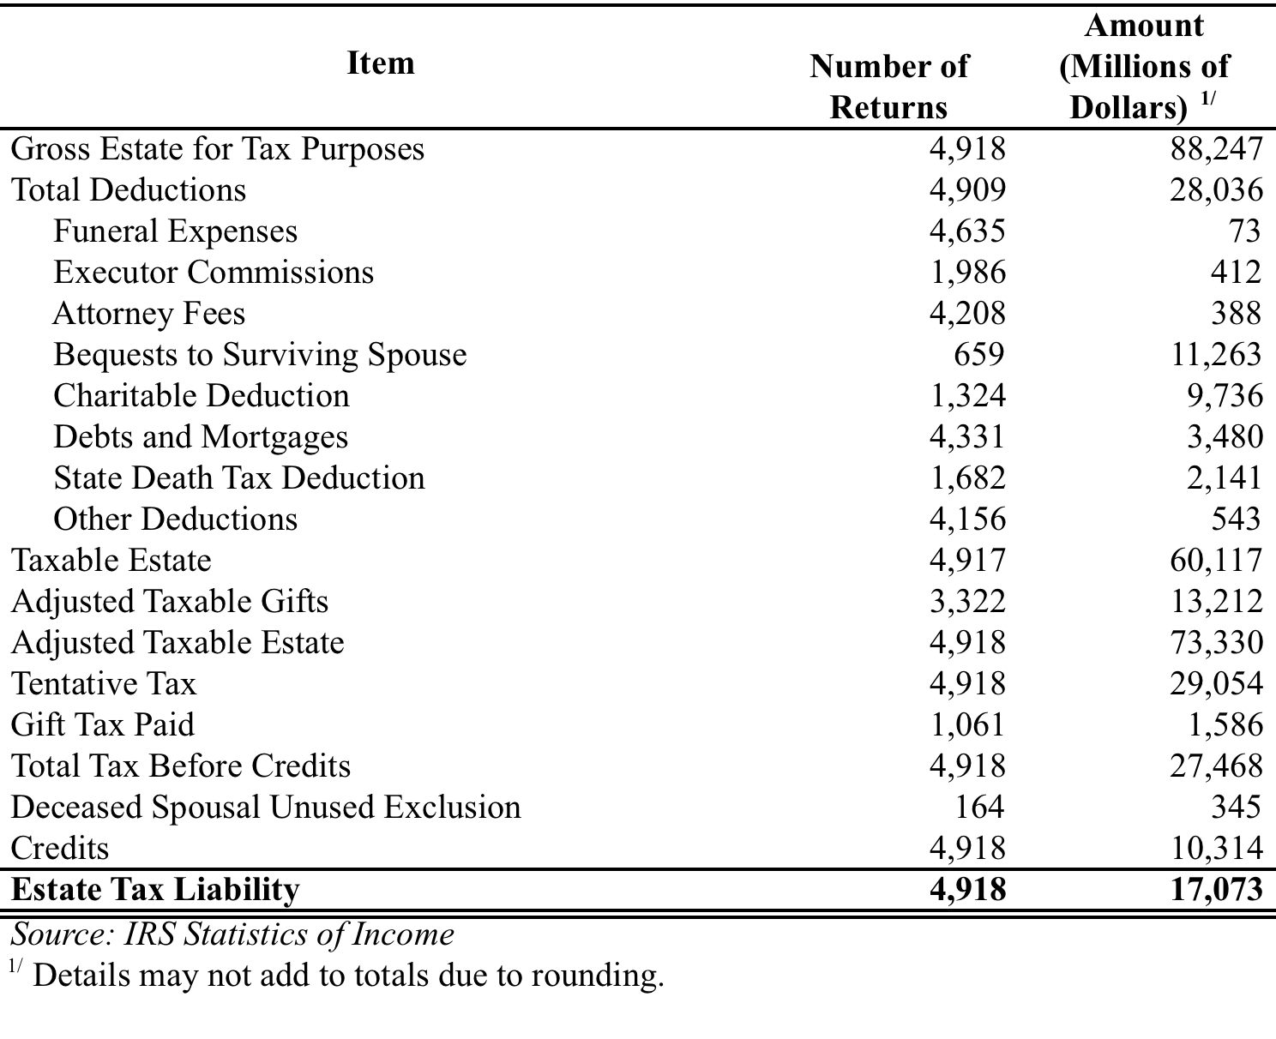

Table 4 shows a breakdown of the composition the gross estate for all 2015 filers. The two largest components of wealth are publicly traded stock (24.9%) and business assets (23.2%).

Table 4 – Composition of Gross Estate, by Type of Property, 2015
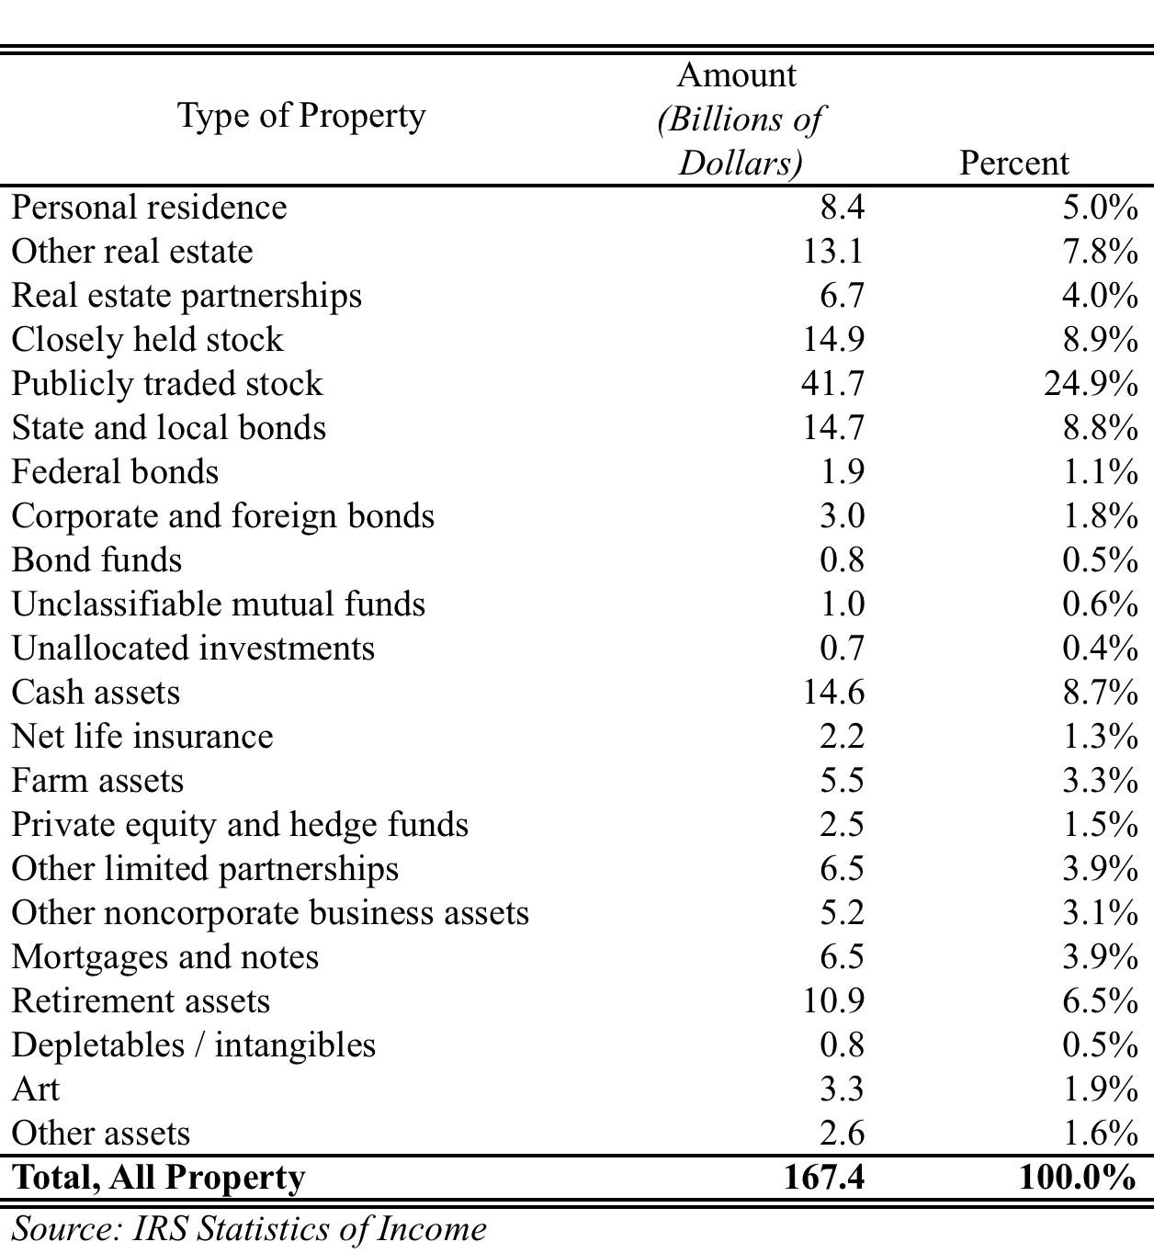

Personal residences account for only 5% of assets held until death. Other financial assets including cash, net life insurance and bonds account for about 20%.

Table 5 shows historical estate and gift tax collections and their relationship to total budget receipts. In 1967, the estate and gift tax accounted for 2% of total government revenues. This figure held reasonably constant until the tax reforms enacted in 1976. After the 1976 Tax Act, estate and gift tax revenues as a percent of total revenues began to fall, first to a little below 1% then rising slightly to about 1.5%. Beginning with the estate tax reforms enacted in 2001 and subsequently modified in 2012, estate and gift tax revenues have continued to drop to about .6% of total revenues today.

Table 5 – Historical Estate and Gift Tax Collections, (Billions of Dollars)

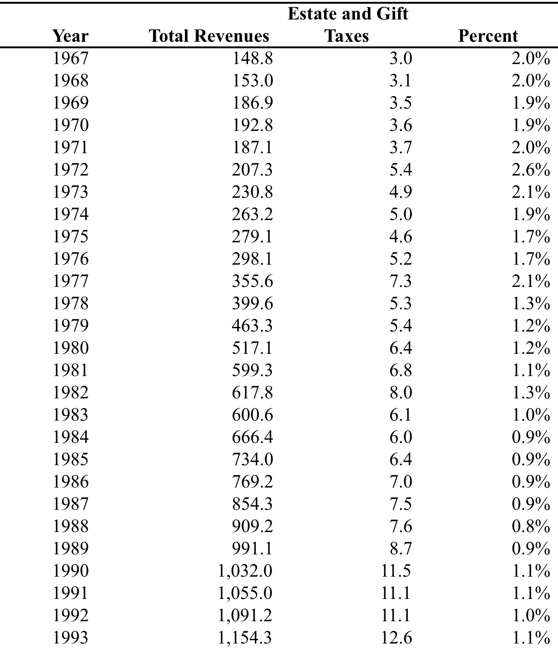

Table 5 – Historical Estate and Gift Tax Collections (Billions of Dollars), continued

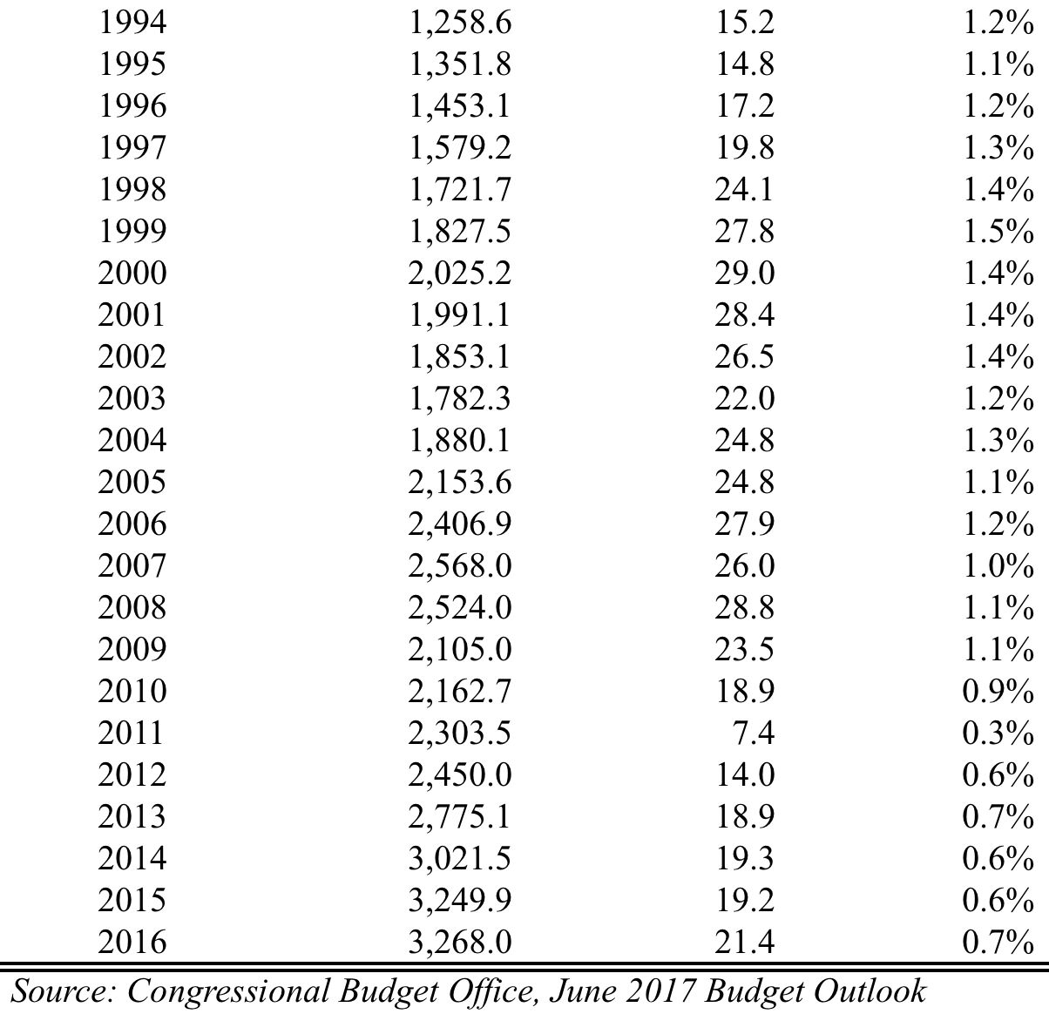

Table 6 summarizes gift tax collections for tax year 2014, the most year data were available. In 2014, approximately 200,000 individuals filed gift tax returns, however most of the gifts were non-taxable. These related to individuals who claimed the annual gift tax exclusion or married couples who chose to combine their exclusion. We focus here on gifts made in the current year, and not on cumulative gifts and credits claimed in prior years. In 2014, approximately 3,000 individuals filed gift tax returns for taxable gifts of about $7.6 billion and paid gift tax of approximately $1.6 billion. Most of the gift tax, in excess of 95%, was paid on gifts that were in excess of $1 million.

Table 6 – Tax On Current Period Gifts, 2014

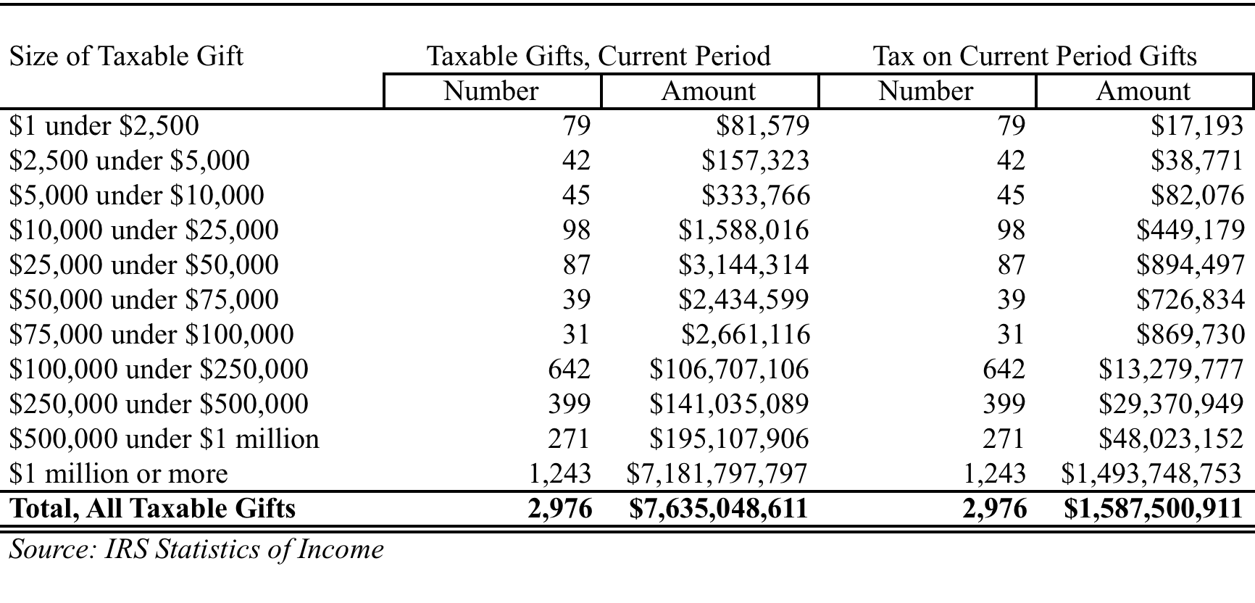

Reasons For Change

Under current law, estate and gift taxes appear to affect few families based on revenues collected. However, a substantial number of Americans must plan for the potential that estate and gift taxes could create financial hardship or threaten the survival of closely-held and family businesses. Historically, the tax was never meant to be a permanent tax but rather, as explained above, to provide a source of funding for wars and national emergencies.

Because the tax falls disproportionately on business owners, it is likely that the tax slows business growth and capital formation. It may also affect overall saving, as individuals reduce their saving to avoid the tax. Small businesses are particularly hard hit by the tax because they are likely to lack the resources and liquidity to mitigate its effects. This often results in businesses being sold in order to pay the tax. Finally, many individuals engage in sophisticated – and expensive – tax planning strategies to reduce the impact of the tax. This is an inefficient allocation of resources and will generally result in an economy that is less productive.

Options For Relief From Federal Estate, Gift and GST Taxes

In this report, we analyze three standalone options for relief from the federal estate, gift and GST taxes that would help reduce the tax burden on business owners. Option A would completely repeal of the federal estate, gift and GST taxes and retain the current law step-up in basis rules. Option B would also completely repeal the estate, gift and GST taxes but replace the current law step-up in basis with a modified regime that limits the step-up to the dollar amount of the personal estate tax exemption, presently $5.49 million, and index this amount for subsequent inflation; Option C retains the current estate, gift and GST system and step-up in basis rules, but lowers the maximum estate tax rate to 20 percent, which is equivalent to the current capital gains rate. .

Review Of JCT Estimates and Methodology

The JCT relies on a microsimulation model of federal estate and gift tax liability. In microsimulation, revenue estimates are built from the “bottom up” by focusing on how individual taxpayers are affected by a change in law. The estimates are then aggregated to arrive at an economy-wide total.

The JCT model relies on a sample of estate tax returns that has been adjusted to reflect the likely population of individuals that would be subject to the tax. Currently, these individual would have a gross estate in excess of $5.49 million in 2017. The model is calibrated to match forecasts of estate and gift tax receipts given current law tax parameters. Next, an alternative or counterfactual set of parameters is imposed and the model examines the difference in revenues under both regimes.

Revenue estimates always take into account taxpayer behavior. For example, if the gasoline tax were increased, we would expect that individuals would alter their driving habits to offset some of the effect of the tax. This behavior would reduce the amount of revenue that would be collected if one were to assume no behavioral adjustment.

Perhaps unlike most taxes, estate and gift taxes are likely to induce strong behavioral effects that will affect both estate tax revenues and income tax revenues. The JCT identifies five such effects:

- Changing the timing and amount of inter vivos giving. Here, it is assumed that individuals exploit differences in the tax rates between the estate and income tax. For example, differences in rates may alter the relative advantages of lifetime giving or bequests at death.
- Changing the timing and amount of charitable contributions claimed on income and estate tax returns. If estate taxes are reduced, individuals will experience an increase in wealth that would, generally, cause them to give more (wealth effect). Alternatively, reducing the tax rate will reduce the benefit of making a charitable contribution (price effect). The JCT’s reading of the extant literature suggests that the price effect dominates and a reduction in the estate tax rate would lead to an overall reduction in charitable giving and a subsequent increase in income tax revenues.
- Changing the amount of capital gains realized on income tax returns. Capital gains realizations are sensitive to both income tax rates and estate tax rates. A third factor affecting capital gains realizations is the step-up in basis that will prevent any capital gains tax to be paid on assets in the estate. As the estate tax is reduced, the JCT assumes that certain individuals will find it more advantageous to reduce current realization and keep appreciated assets in the estate. This will have the effect of reducing federal income tax revenues.
- Shifting various deductions between estate and income tax returns. Some deductions (e.g., some medical expenses) can be claimed on either the estate tax return on the income tax return. Depending on the tax situation, an individual might find it more advantageous to claim deduction on the income tax return if the estate tax was sufficiently reduced.
- Expanding or contracting opportunities for the use of tax planning and mitigation techniques. The estate tax is rife with opportunities for tax planning. For example, if the gift tax were substantially reduced or eliminated, the JCT would assume that individuals would transfer assets to beneficiaries that would be in a lower tax bracket to reduce their tax liability.

Revenue Estimates

Because estate tax returns are confidential, there is no publicly available source of micro data to simulate tax changes on an individual basis. In preparing our estimates, we rely on several data sources. In particular, our starting point is an estimate of the net worth of households that would be most likely to be affected by the estate tax. Currently, this would be a household with a gross estate in excess of $5.49 million. Table 5 shows estimates prepared by the IRS Statistics of Income (SOI) Division that captures this population in 2013.

Table 7 – Estimates of Personal Wealth for Top Wealth Holders, 2013

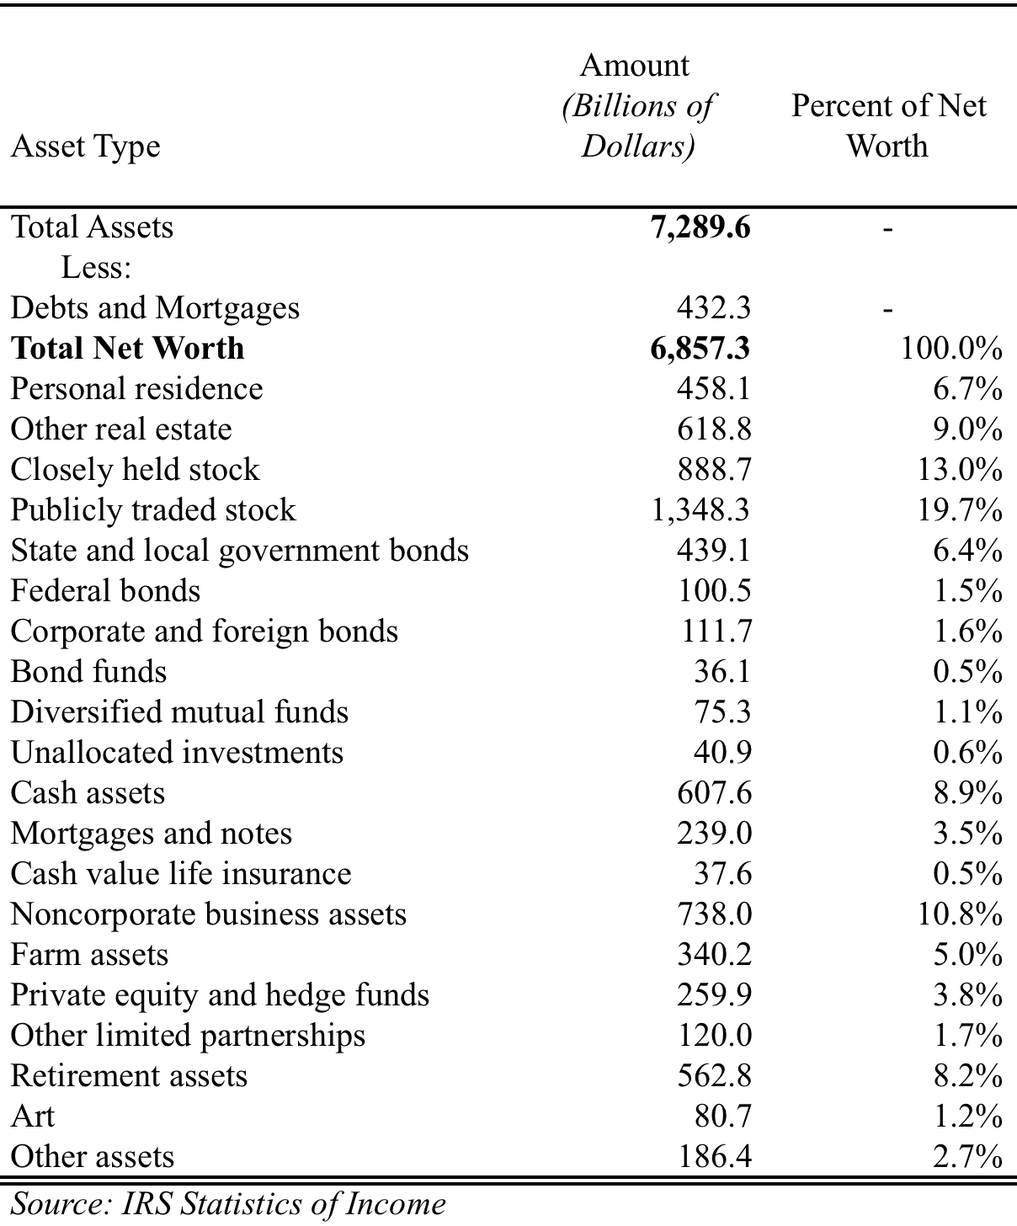

The figures represent approximately 600,000 households with about $7.3 trillion in total assets and $6.9 trillion in net worth. As you can see, the asset categories are slightly different than shown on estate and gift tax returns. The proportion of assets associated with businesses is slightly higher than on estate tax returns.

To this population of high wealth holders, we apply a mortality rate to reflect the likelihood that they would file an estate tax return in any year. We calibrate these results to match our forecast of estate and gift tax revenue.

In calculating the revenue effect of each option, we model three primary behavioral effects: (i) a reduction in lifetime giving; (ii) a reduction in charitable giving; and (iii) a reduction in capital gains realization.

Lifetime giving

Empirical research has shown that wealthy individuals are sensitive to the relative taxation of lifetime gifts and bequests. Because gift taxes are paid on a “tax exclusive” basis while bequests are paid on a “tax inclusive” basis, gifts have a relative advantage. As estate rates fall, lifetime gifts lose this advantage, lifetime giving declines and revenue is lost from the gift tax. While important, this effect is quite small.

Charitable giving

As explained above, a reduction in the estate tax has two offsetting effects with respect to charitable giving: a price effect and a wealth effect. The price of leaving a charitable bequest is one minus the estate tax rate. (E.g., at a 40% estate tax rate, the “price” of making a charitable bequest of $1 is 60 cents because of the tax deduction.) As the estate tax rate declines, this price rises and fewer charitable bequests will be made. This is the price effect.

Alternatively, a reduction in the estate tax rate will result in more wealth accruing to wealth individuals and higher wealth is correlated with increased charitable giving. This is the wealth effect. As we indicated above, the JCT believes that, according to their reading of the empirical literature, that the price effect dominates and a reduction in the estate tax will result in a reduction in charitable bequests. In arriving at our estimate of this effect, we adopt the JCT estimate of the price elasticity of giving (-1.6) and wealth elasticity (1.2). Elasticity measures the behavioral response of taxpayers. For example, a price elasticity of -0.5 means that if prices went up by 10%, demand would be reduced by 5%. A brief description of how these elasticities are calculated is contained in Appendix II.

Research into the effect of the estate tax on overall charitable giving also suggests that lifetime giving is reduced when the estate tax is lowered. This will result in an increase in income tax revenue from two sources. First, charitable deductions claimed on individual tax returns will be lower resulting in more income tax revenue. Second, invested assets no longer held by non-taxable entities will make their way into the taxable sector and generate additional interest and dividend income. In estimating this effect, we begin with JCT’s estimate of the effect for a similar tax proposal and calibrate the result to match the specifics of each option.

Capital Gains Realizations

The decision to sell an asset and realize a capital gain is a discretionary event and will depend on three features of our tax system: the current law capital gains rate, the estate tax rate and the step-up in basis for assets in the estate and passed on to heirs. Generally, as the estate rate falls, it becomes more advantageous to hold on to appreciated assets and pay the estate tax. Also, a step-up in basis creates a “lock-in” effect where owners of appreciated property will delay realizing a capital gain so their heirs can avoid taxes on the appreciation. As the step-up in basis rules are modified, this will reduce the lock-in effect and result in an increase in realizations before death.

Our estimates attempt to capture both these effects in a manner that is similar to JCT’s. As the JCT explains:

“For proposals that repeal, or substantially reduce, the estate tax while reducing or eliminating the step-up in basis on assets held at death, the Joint Committee staff models both the deferral of capital gains realizations that results from the repeal of the estate tax and the switch to carryover basis and the taxation of capital gains on inherited assets, some of which may now be subject to capital gains taxation as a result of carryover basis.

For proposals that retain some step-up in basis, the Joint Committee staff considers the amount of additional basis that might be allocated to estates and how heirs might dispose of assets that have increased in value. The results of the Joint Committee staff’s models indicate that the increased lock-in effect on capital gains realizations from the elimination of the estate tax tends to dominate the increased capital gains realization by heirs as a result of elimination of basis step-up.”

Other Behavioral Effects

There are two behavioral effects that we do not include in our estimates that the JCT does. One relates to the shifting of assets to family members to take advantage of lower individual rates. We exclude this effect from our estimates because our anecdotal evidence suggests that, while this may have been a popular tax-planning strategy in prior years, it is not practiced much today, mostly because of provisions relating to the unearned income of children (i.e., the “Kiddie Tax”).

A second effect we do not include is the result of what the JCT calls “form shopping”. Because certain types of deductions (e.g., funeral expenses, some medical expenses) can be deducted on either the last income tax return filed by the decedent or the estate tax return, it’s possible that some individuals will choose the return with the lower tax rate. We don’t include this effect because we have no data to estimate its magnitude but we believe this effect to be de minimus. The JCT has indicated this effect is probably negligible.

We present our revenue estimates of each option below. Our estimates assume that the provisions are effective for decedents dying on or after January 1, 2018. The estimates include changes in revenues attributable to the estate, gift, GST and individual income taxes.

Option A: Complete Repeal of Federal Estate, Gift and GST Taxes

The first option we examine is complete repeal of the estate, gift and the GST taxes. In this option, we also retain the current step-up in basis rules.

As explained above, in our model we estimate three separate behavioral effects: (i) a reduction in lifetime giving and the reduction in gift tax revenues; (ii) the increase in income taxes due to a reduction in lifetime charitable giving; and (iii) a reduction in income tax revenues due to a reduction in capital gains realizations. We estimate that if this option were enacted, federal estate, gift and GST revenues would be reduced by $280.2 billion.

Option B: Complete Repeal of Federal Estate, Gift and GST Taxes With a Modified Step-up In Basis

This option is similar to Option A, but imposes a modified step-up in basis regime. Specifically, the current law step-up in basis for appreciated assets would exempt from capital gains tax the value of inherited assets up to the existing personal estate tax exemption amount (currently $5.49 million for 2017) and index this amount for inflation occurring after 2018. Our estimate assumes a substantial behavioral response for taxpayers affected by the limitation who would respond to the change by increasing their capital gains realizations as explained above. This effect would be offset somewhat by the reduced realizations of heirs who would now have to pay higher capital gains taxes on the sale of inherited assets. However, the net effect is to reduce the estimate of complete repeal by about $100 billion. We estimate this proposal would reduce federal budget receipts by $184.7 billion.

Option C: Reduce The Maximum Tax Rate to 20%

Option C retains the current law treatment of estate, gift, GST taxes and current step-up in basis rules. Option C lowers the maximum estate, gift and GST tax rate to 20%. In preparing our estimate, we assume a similar behavioral response with respect to charitable giving and capital gains realizations. We also assume the current law unified credit is unchanged. If this provision were to become law, we estimate that federal budget receipts would be reduced by $147.2 billion.

Table 8 summarizes these revenue effects for fiscal years 2018-2027 for decedents dying on or after January 1, 2018:

Table 8 – Summary of Revenue Effects, Fiscal Years 2018 – 2027

Description | Revenue Effect (Billions of Dollars)
Option A: Full Repeal of Estate, Gift and GST taxes; Retain Current Law Step-up. | -280.2
Option B: Full Repeal of Estate, Gift and GST taxes with a Modified Step-up In Basis limited to the amount of the personal estate tax exemption and indexed to inflation. | -184.7
Option C: Maintain the Current Estate, Gift and GST System with Full Step-up in Basis and Reduce the Current Maximum Tax Rate to 20% | -147.2

We point out that our estimates assume that each option is treated as a stand-alone proposal and not part of a larger tax reform plan. If either option becomes part of a tax plan that reduces individual and business taxes – as is being contemplated – then the revenue losses would be smaller.

What Is The Cost Of Complying With The Tax?

Some authors have speculated that the cost of complying with the estate and gift tax exceeds the revenue collected. Recently, the Tax Foundation estimated these compliance costs to be approximately $20 billion – about the same amount as the tax itself.
The Office of Management and Budget estimates that just filling out the estate tax form (Form 706) will take individuals over 2 million hours. And this does not include tax-planning costs. In a recent survey, Family Enterprise USA found that 19% of business owners responded that they undertook tax-planning activities including paying an average of $75,000 in annual life insurance premiums and another $170,000 in other planning costs. In addition, they reported spending an average of about 13% of their time planning for the estate tax.

Perhaps the most common type of estate tax planning is to purchase life insurance to cover the cost, or a portion of the cost, of the estate tax when a business owner dies. To get a sense of the magnitude of this compliance burden imposed by the federal gift and estate tax, we obtained a quote from Pacific Life on a $3,500,000, 15-year term life insurance policy for a 66-year old male with an annual premium of about $40,000 averaged over several risk classes. If we assume that each of the approximately 600,000 estates that could be subject to the estate tax each took out a $3.4 million dollar policy to cover the average estate tax (Table 1) then the total cost would be about $24 billion – significantly more than the amount collected. This estimate does not include other estate planning strategies. Clearly, the estate tax is an inefficient tax, resulting in a misallocation of resources and complete repeal would result in a more productive economy.

Conclusions

In this paper, we have presented revenue estimates of three (3) options to reform the federal gift and estate tax. The options range from out-right repeal to a reduction in the estate tax rate to 20%. We have relied on assumptions and a methodology that is similar, though not identical to, the JCT. Our estimates show that these options would reduce federal revenues by between $280 billion and $147 billion. Furthermore, we suggest that the annual costs of complying with the estate tax could be greater than the tax collects – a good indication that the tax repealing the tax would result in a more efficient tax system.

Appendix I – Chronological History of the Estate and Gift Tax

Year | Description
1916 | Estate Tax Enacted.
1918 | Tax base expanded to include: spouse’s dower rights, exercised general powers of appointment, and life insurance over $40,000 payable to estate; charitable deduction added.
1924 | Gift tax enacted; State death tax credit added; revocable transfers included in tax base
1926 | Gift Tax Repealed
1932 | Gift Tax Reintroduced
1935 | Alternative Valuation
1942 | Tax base expanded to include: all insurance paid for by decedent; most powers of appointment, and community property  (less spouse’s actual contribution to cost)
1948 | Marital replaced 1942 community property rules
1951 | Power of appointment rule relaxed
1954 | Life insurance rules modified to exclude insurance the decedent never owned
1976 | Unified estate and gift taxes; added generation-skipping transfer tax (GST), orphan deduction, carryover basis rule, special valuation and payment rules for small business and farms; increased marital deduction
1980 | Carryover basis rule repealed retroactively
1981 | Unlimited marital deduction; tax base changed; full value pension bene ts, 1⁄2 joint property automatically excluded; orphan deduction repealed
1986 | ESOP deduction added and GST modified
1987 | Phase-out of graduated rates and unified credit for estates over $10 million
1988 | QTIP allowed for marital deduction; estate freeze and GST modified
1989 | ESOP deduction dropped
1997 | Qualified Family-owned Business deduction, conservation easement introduced; 1987 phase out of unified credit revoked.
2001 | EGTRRA. Gradual Repeal of the Estate Tax
2010 | Estate Tax is repealed for one year, but decedents can choose to adopt a modified step-up in basis.
2012 | American Tax Relief Act of 2012 (enacted January 2nd, 2013). Put in place our existing estate tax regime.
Source: IRS Statistics of Income, The Estate Tax: Ninety Years and Counting

Appendix II – Measuring Taxpayer Response to a Tax Change

Economists measure how individuals and businesses respond to price changes by way of a concept known as “elasticity”. By definition, the price elasticity of demand is the percentage change in the quantity demanded of a certain good divided by the percentage change in the price of the good. Mathematically, the price elasticity of demand is calculated as:

where Q is the quantity demanded, P is the price of the good and Δ is the observed change.

For example, if the price of certain good rises by 10% and the quantity demanded remains unchanged, then the price elasticity is zero. Economists refer to a commodity with a zero elasticity of demand as “inelastic” or unresponsive. Alternatively, if individuals respond to a 10% price increase by reducing their consumption by 10% then the elasticity of demand is 1.0 (in absolute value).

Tax changes will affect the price of taxed goods and the calculation of the price elasticity of demand will incorporate the change in the after tax price and the resulting change in the quantity demanded. For example, if the federal gasoline tax causes the price of a gallon of gas to increase by 10% and individuals reduce their consumption of gasoline by 5% then the price elasticity of demand is -0.5.

Generally, if a certain commodity has a price (or tax) elasticity of 0.5 (in absolute value), it is referred to as “relatively inelastic”. If individuals reduce their purchases of the taxed commodity by more than the increase in price, then the price elasticity is greater than -1.0 (in absolute value) and the good is considered “highly elastic”.

As a rule of thumb, when a commodity has a price elasticity less than 1.0 (in absolute value), then the government can raise revenue by increasing the tax rate (because the percentage reduction in demand (ΔQ/Q) will be less than the percentage reduction in price (ΔP/P) and revenues will go up. Conversely, if the price elasticity is greater than 1.0 (in absolute value) then the reverse is true – the government can actually raise revenue by reducing the tax rate. Theoretically, the tax rate at which the elasticity is exactly equal to 1.0 is sometimes referred to as the “revenue maximizing” tax rate.

Price (or tax) elasticities are usually calculated econometrically by relying on measurements of prices, taxes and quantities demanded, either over time (time series analysis), at a point in time (cross section analysis) or a combination of both (pooled, or longitudinal data analysis).

See “The Estate Tax: Ninety Years and Counting”, Statistics of Income, IRS, for a more in-depth discussion of the history of the federal estate tax.
Appendix I contains a summary of major changes in the estate tax since 1916.
Estate tax returns filed in 2015 would generally be for individuals who died in 2014.
Gross estate for tax purposes includes a special use valuation on certain business property and a reduction in the value of conservation easements.
In arriving at the figure for business assets, we include real estate partnerships, closely held stock, farm assets, other limited partnerships and other non-corporate business assets.
The sharp drop in revenues in 2011 is due to the temporary provisions put in place because of the repeal of the estate and gift tax. In addition, gift tax revenues spiked in 2013 due primarily to provisions contained in the Tax Relief, Unemployment Reauthorization and Job Creation Act which significantly increased the credit available to offset lifetime gifts.
See JCX-76-12, Modeling the Federal Revenue Effects of Changes in Estate and Gift Taxation, November 9, 2012.
Ibid., page 17.
Revenues would increase through two primary channels. First, there would be fewer charitable donations claimed on individual tax returns so individual tax revenues would increase. Second, fewer assets in the non-taxable, charitable section would result in these assets being deployed in the taxable economy where they would result in additional, taxable interest and dividend income.
See David Joulfaian, “Charitable Giving in Life and at Death,” in Gale, Hines, and Slemrod (eds.), Rethinking Estate and Gift Taxation, Brookings Institution, 2001. See also Auten and Joulfaian, “Charitable Contributions and Intergenerational Transfers,” Journal of Public Economics, vol. 59, 1996, pp. 55-68. And Pamela Greene and Robert McClelland, “The Effects of Federal Estate Tax Policy on Charitable Contributions.” Congressional Budget Office, Technical Paper 2001-2, 2001.
See JCX-76-12, Modeling the Federal Revenue Effects of Changes in Estate and Gift Taxation, November 9, 2012.
Ibid.
Ibid. P 36.
In their estimate of H.R. 1105, “The Death Tax Repeal Act of 2015”, the JCT calculated a revenue loss of about $269 billion but they assumed a slightly different effective date. In addition, H.R. 1105 kept the gift tax in place.
“The Compliance Costs of IRS Regulations”, Scott Hodge, The Tax Foundation, June 2016.
Federal Register, Vol. 82, No. 58, March 28, 2017.
An elasticity of zero implies that individuals do not change their behavior when confronted with a higher (or lower price). In revenue estimating, this is sometimes referred to as a “static” estimate. This is a misnomer, as all revenue estimates incorporate taxpayer behavioral responses. A “dynamic” revenue estimate generally refers to the effect of changes to the macro economy that a tax change may induce.

